

Lab Activity 04 – AJAX
Name | Matric No
CHEW CHUAN KAI | A23CS0062

Exercise 1
- Synchronous vs. Asynchronous Execution
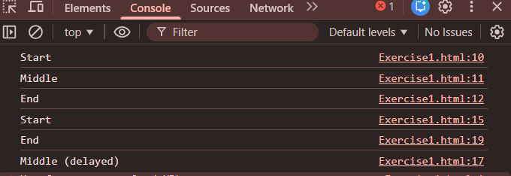
- Async Implementations
  - XMLHttpRequest (XHR)
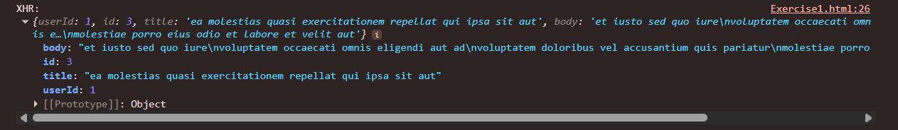
  - jQuery AJAX
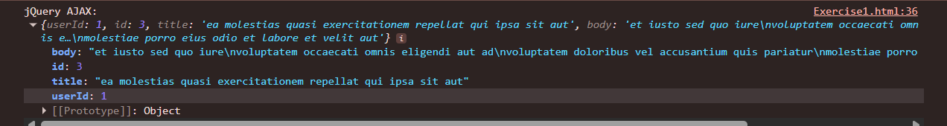
  - Promises
  - Fetch API
  - Async/Await
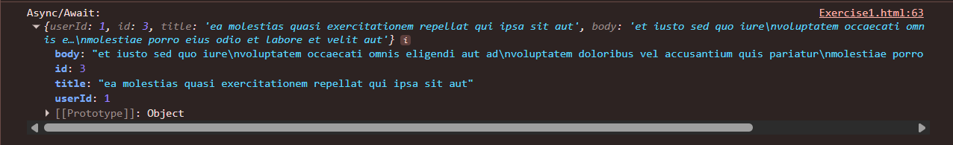
Exercise 2
- Display JSON in Console
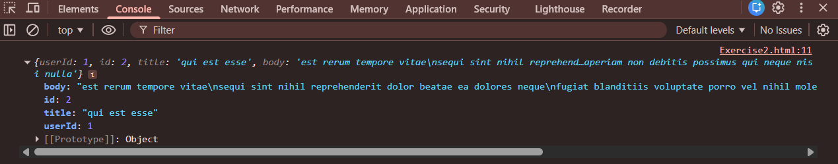
- Display JSON in <pre> Tag
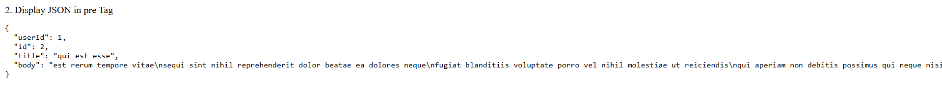
- Convert JSON to HTML Table

Exercise 3
- Using $.ajax() for GET Request
  - posts/5
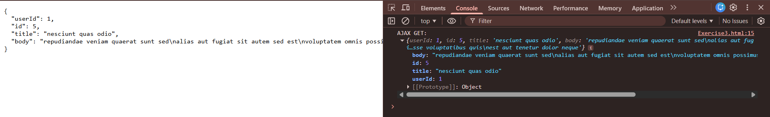
  - users/3
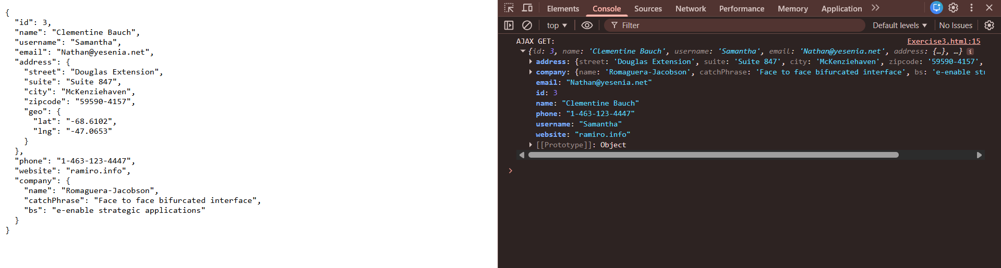
  - todos/1
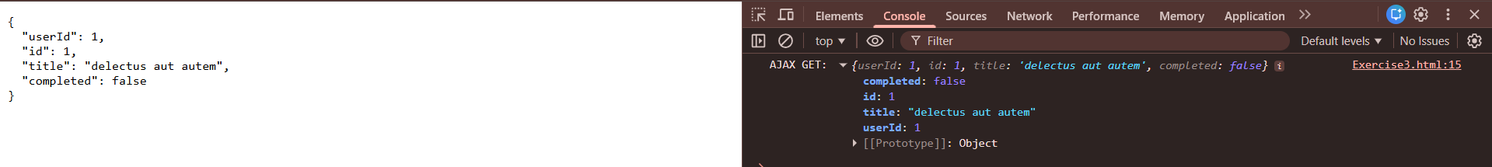
- Using $.get()
  - posts/5
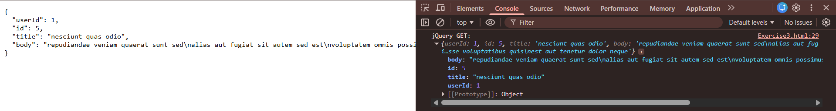
  - users/3
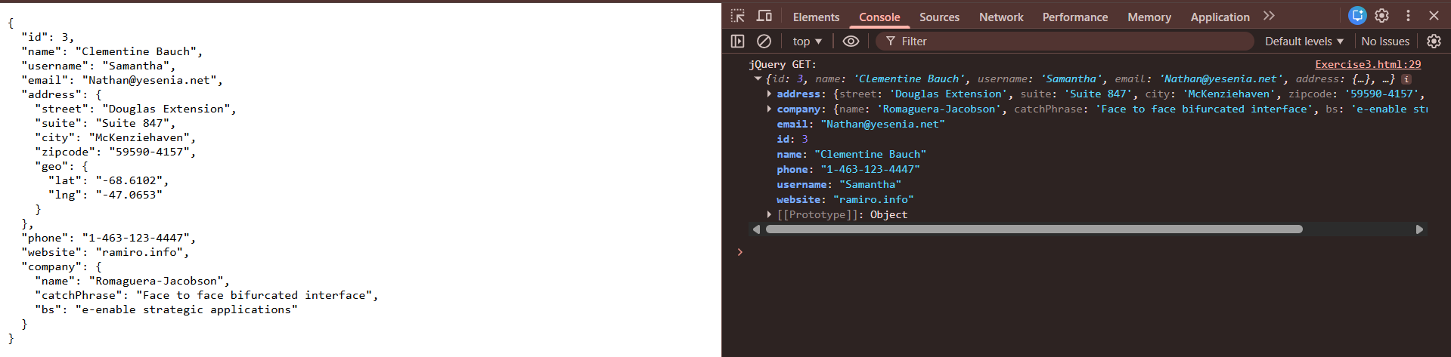
  - todos/1
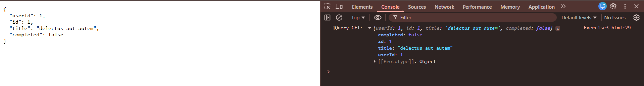
- Using $.getJSON()
  - posts/5
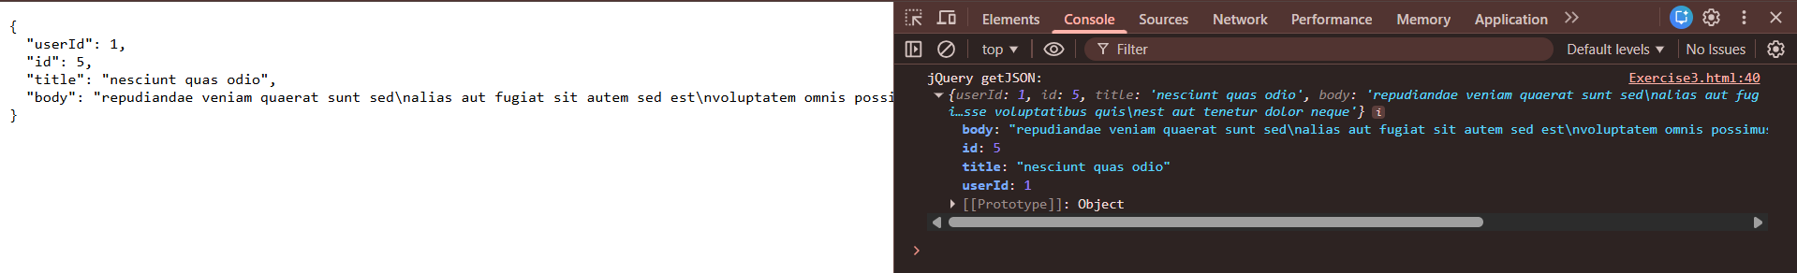
  - users/3
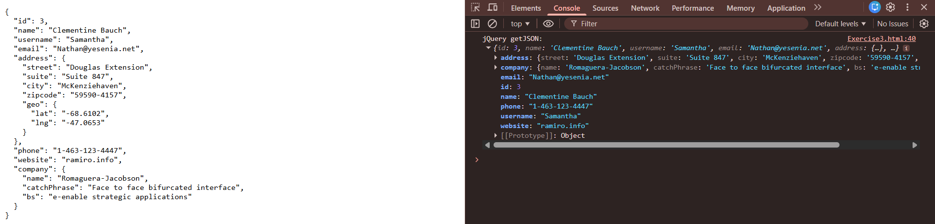
  - todos/1
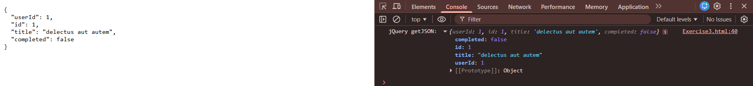
- Simulating a POST Request
